Novel Coronavirus(2019-nCoV)
Situation Report – 14 - ERRATUM

Data as reported by 3 February 2020*

HIGHLIGHTS

- No new countries reported cases of 2019-nCoV in the past 24 hours.

- WHO has developed a dashboard for Novel coronavirus (2019-nCoV) with the number of confirmed cases globally, which includes cases in China by provinces, regions and cities, as well as confirmed cases outside China by country.

- WHO has prepared a list of Q&A to respond to queries WHO is receiving from various organizations and individuals.

- Working with technical experts in health operations, WHO operational support and logistics has developed a “2019-nCoV kit”, similar to prepared treatment kits used for outbreaks of other high threat pathogens. In the coming days, the costing, procurement and assembly of these kits will be a priority.

SITUATION IN NUMBERS
total and new cases in last 24 hours

Globally
17391 confirmed (2838 new)

China
17238 confirmed (2831 new)
2296 severe (186 new)
361 deaths (57 new)

Outside of China
153 confirmed (7 new)
23 countries
1 death

WHO RISK ASSESSMENT

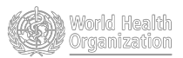
China | Very High
Regional Level | High
Global Level | High

Figure 1. Countries, territories or areas with reported confirmed cases of 2019-nCoV, 3 February 2020

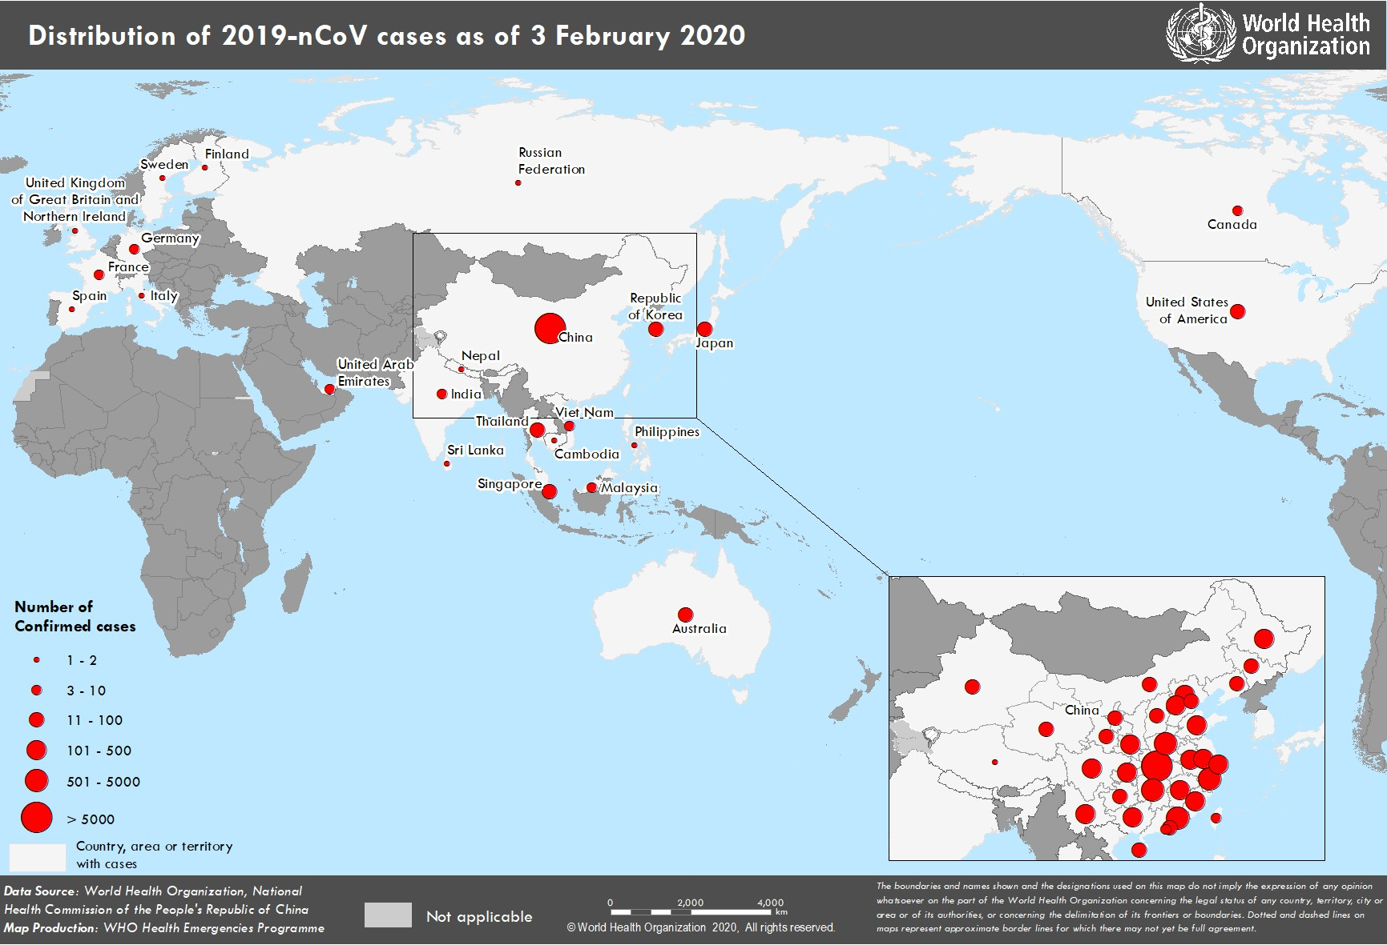

*The situation report includes information provided by national authorities as of 10 AM Central European Time

TECHNICAL FOCUS: Operational Support and Logistics

WHO Operational Support and Logistics (OSL) is working to support the 2019-nCoV response, both at the global level and directly with Member States. Amongst these activities, WHO OSL has updated the Disease Commodity Package (DCP), which has been published here. This document provides guidance on commodities required for all aspects of response. WHO OSL has also been working to develop global commodity cost estimates for the 2019-nCoV response, which will aid in global strategic response planning and financing.

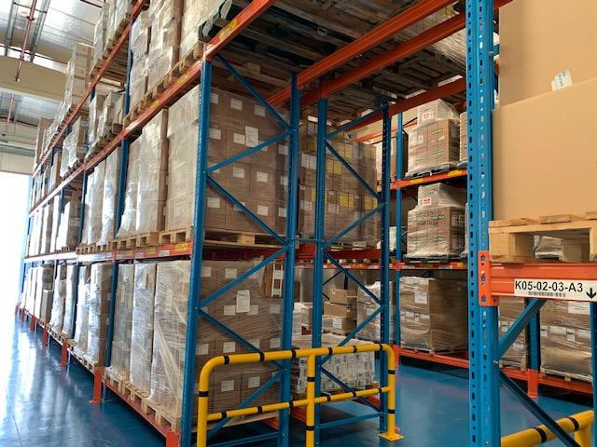

Working with technical experts in health operations, WHO OSL has developed a “2019-nCoV kit”, similar to prepared treatment kits used for cholera, Ebola and other high threat pathogens in emergencies. In the coming days, the costing, procurement and assembly of these kits will be a priority.

Through the Pandemic Supply Chain Network (PSCN), a market survey has been distributed to over 40 organizations to understand the availability, distribution and forecasting of crucial response commodities throughout the world. A report of the findings will be redistributed to all partners. The Network is exploring operational options within its stakeholders to ensure in particular that critical personal protective equipment is secured and distributed to appropriate locations. Additional stakeholders are encouraged to join the Pandemic Supply Chain Network by contacting WHO OSL.

Guidance is currently under development for managing the logistics associated with case management, focusing on isolation, triage and standard treatment centre configuration.

OSL is setting up a global supply chain system and a coordination mechanism between responders and suppliers to ensure access to essential commodities for countries/populations most in need.
SURVEILLANCE

Table 1. Confirmed cases of 2019-nCoV acute respiratory disease reported by provinces, regions and cities in China, 3 February 2020

Province/Region/City | Confirmed Cases
Hubei | 11177
Zhejiang | 724
Guangdong | 683
Henan | 566
Hunan | 521
Anhui | 408
Jiangxi | 391
Chongqing | 300
Jiangsu | 271
Sichuan | 254
Shandong | 246
Beijing | 212
Shanghai | 193
Fujian | 179
Shaanxi | 128
Guangxi | 127
Heilongjiang | 118
Hebei | 113
Yunnan | 109
Liaoning | 70
Hainan | 70
Shanxi | 66
Gansu | 51
Tianjin | 49
Guizhou | 46
Inner Mongolia | 33
Jilin | 31
Ningxia | 31
Xinjiang | 24
Hong Kong Sar | 15
Qinghai | 13
Taipei | 10
Macao Sar | 8
Xizang | 1
Total | 17238

ERRATUM: Please note, due to a transposition error, several numbers in the table above were incorrectly positioned in the original publication of this report. They are corrected here.

Table 2. Countries, territories or areas with reported confirmed 2019-nCoV cases and deaths. Data as of 3 February 2020

South-East Asia
WHO Regional Office | Country/Territory/Area |  | Confirmed (new) cases | Total (new) cases with travel history to China | Total (new) cases with possible or confirmed transmission outside of China | Total (new) cases with site of transmission under investigation | Total (new) deaths
 | China*  Japan |  | 17238  (2831)  20 | 17 | 3 | 0 | 361 (57)  0
Western Pacific
 | Republic of Korea |  | 15 | 8 | 4 | 3 | 0
 | Viet Nam |  | 8 (1) | 6 (1) | 2 | 0 | 0
 | Singapore |  | 18 | 18 | 0 | 0 | 0
 | Australia |  | 12 | 12 | 0 | 0 | 0
 | Malaysia |  | 8 | 7 | 1 | 0 | 0
 | Cambodia |  | 1 | 1 | 0 | 0 | 0
 | Philippines |  | 2 | 1 | 0 | 1 | 1
 | Thailand  Nepal |  | 19  1 | 18  1 | 1  0 | 0  0 | 0  0
 | Sri Lanka |  | 1 | 1 | 0 | 0 | 0
 | India |  | 3 (1) | 3(1) | 0 | 0 | 0
Region of the Americas | United States of America |  | 11 (3) | 8(1) | 2(1) | (1) | 0
 | Canada |  | 4 | 3 | 0 | 1 | 0
 | France Finland  Germany |  | 6  1  10 (2) | 5  1  2 (2) | 1  0  8 | 0  0  0 | 0  0  0
European Region | Italy |  | 2 | 2 | 0 | 0 | 0
 | Russian Federation |  | 2 | 2 | 0 | 0 | 0
 | Spain |  | 1 | 0 | 1 | 0 | 0
 | Sweden |  | 1 | 1 | 0 | 0 | 0
 | United Kingdom |  | 2 | 1 | 1 | 0 | 0
Eastern Mediterranean | United Arab Emirates |  | 5 | 5 | 0 | 0 | 0
Total Confirmed cases |  | Total | 17391  (2838) | 123 (5) | 24 (1) | 6 (1) | 362 (57)

*Confirmed cases in China include cases confirmed in Hong Kong SAR (15 confirmed cases (1 new)), Macao SAR (8 confirmed cases (1 new)) and Taipei (10 confirmed cases).
Note: Case classifications are based on WHO case definitions for 2019-nCoV.

Figure 2: Epidemic curve of 2019-nCoV cases (n=88) identified outside of China, by date of onset of symptoms and travel history, 3 February 2020
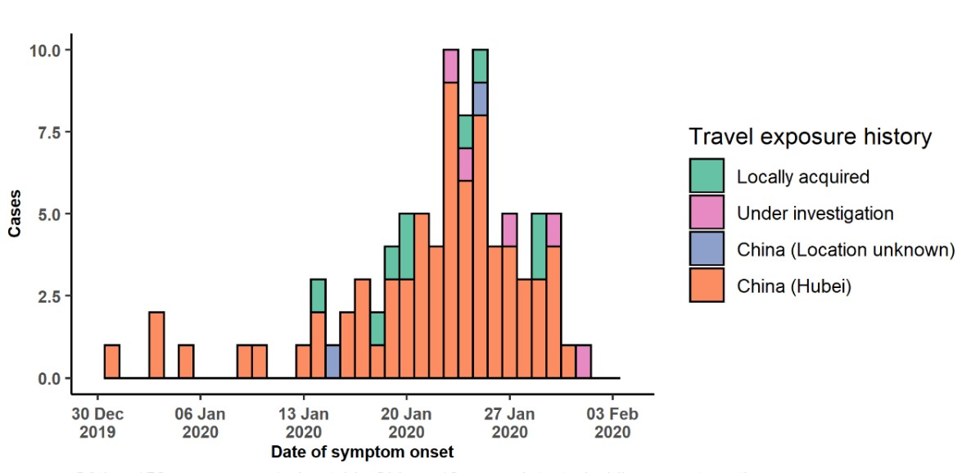

Note for figure 2: Of the 153 cases reported outside China, 12 were detected while asymptomatic. For the remaining 141 cases, information on date of onset is available only for the 88 cases presented in the epidemiologic curve.

Figure 3: Epidemic curve of 2019-nCoV cases (n=153) identified outside of China, by date of reporting and travel history, 3 February 2020
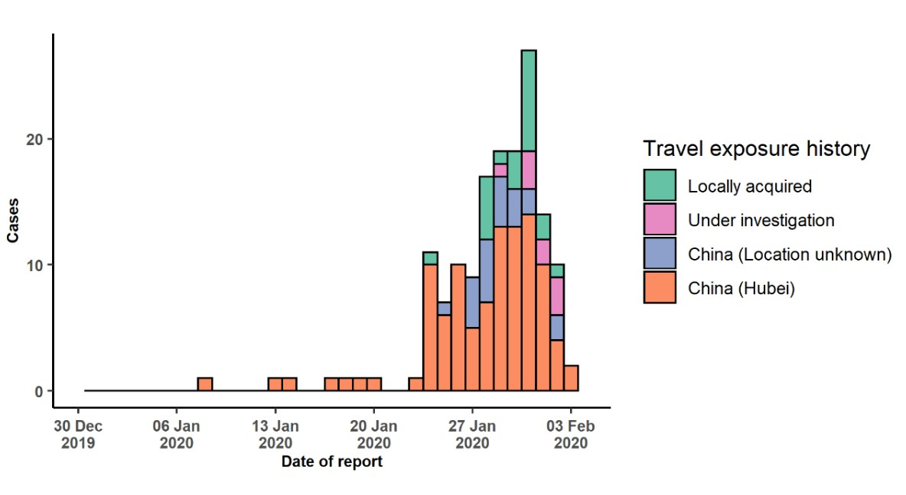

STRATEGIC OBJECTIVES

WHO’s strategic objectives for this response are to:

- Limit human-to-human transmission including reducing secondary infections among close contacts and health care workers, preventing transmission amplification events, and preventing further international spread from China*;
- Identify, isolate and care for patients early, including providing optimized care for infected patients;
- Identify and reduce transmission from the animal source;
- Address crucial unknowns regarding clinical severity, extent of transmission and infection, treatment options, and accelerate the development of diagnostics, therapeutics and vaccines;
- Communicate critical risk and event information to all communities and counter misinformation;
- Minimize social and economic impact through multisectoral partnerships.

*This can be achieved through a combination of public health measures, such as rapid identification, diagnosis and management of the cases, identification and follow up of the contacts, infection prevention and control in healthcare settings, implementation of health measures for travellers, awareness- raising in the population and risk communication.

PREPAREDNESS AND RESPONSE

- WHO has developed a protocol for the investigation of early cases (the “First Few X (FFX) Cases and contact investigation protocol for 2019-novel coronavirus (2019-nCoV) infection”). The protocol is designed to gain an early understanding of the key clinical, epidemiological and virological characteristics of the first cases of 2019- nCoV infection detected in any individual country, to inform the development and updating of public health guidance to manage cases and reduce potential spread and impact of infection.
- WHO has been in regular and direct contact with Member States where cases have been reported. WHO is also informing other countries about the situation and providing support as requested.
- WHO has developed interim guidance for laboratory diagnosis, advice on the use of masks during home care and in health care settings in the context of the novel coronavirus (2019-nCoV) outbreak, clinical management, infection prevention and control in health care settings, home care for patients with suspected novel coronavirus, risk communication and community engagement and Global Surveillance for human infection with novel coronavirus (2019-nCoV).
- WHO has prepared disease commodity package that includes an essential list of biomedical equipment, medicines and supplies necessary to care for patients with 2019-nCoV.
- WHO has provided recommendations to reduce risk of transmission from animals to humans.
- WHO has published an updated advice for international traffic in relation to the outbreak of the novel coronavirus 2019-nCoV.
- WHO has activated of R&D blueprint to accelerate diagnostics, vaccines, and therapeutics.
- WHO has developed an online course to provide general introduction to emerging respiratory viruses, including novel coronaviruses.
- WHO is providing guidance on early investigations, which are critical to carry out early in an outbreak of a new virus. The data collected from the protocols can be used to refine recommendations for surveillance and case definitions, to characterize the key epidemiological transmission features of 2019-nCoV, help understand spread, severity, spectrum of disease, impact on the community and to inform operational models for implementation of countermeasures such as case isolation, contact tracing and isolation. Several protocols are available here: https://www.who.int/emergencies/diseases/novel-coronavirus-2019/technical-guidance/early-investigations
  - WHO is working with its networks of researchers and other experts to coordinate global work on surveillance, epidemiology, modelling, diagnostics, clinical care and treatment, and other ways to identify, manage the disease and limit onward transmission. WHO has issued interim guidance for countries, which are updated regularly.
- WHO is working with global expert networks and partnerships for laboratory, infection prevention and control, clinical management and mathematical modelling.

RECOMMENDATIONS AND ADVICE FOR THE PUBLIC

During previous outbreaks due to other coronavirus (Middle-East Respiratory Syndrome (MERS) and Severe Acute Respiratory Syndrome (SARS), human-to-human transmission occurred through droplets, contact and fomites, suggesting that the transmission mode of the 2019-nCoV can be similar. The basic principles to reduce the general risk of transmission of acute respiratory infections include the following:

- Avoiding close contact with people suffering from acute respiratory infections.
- Frequent hand-washing, especially after direct contact with ill people or their environment.
- Avoiding unprotected contact with farm or wild animals.
- People with symptoms of acute respiratory infection should practice cough etiquette (maintain distance, cover coughs and sneezes with disposable tissues or clothing, and wash hands).
- Within healthcare facilities, enhance standard infection prevention and control practices in hospitals, especially in emergency departments.

WHO does not recommend any specific health measures for travellers. In case of symptoms suggestive of respiratory illness either during or after travel, travellers are encouraged to seek medical attention and share their travel history with their healthcare provider.

